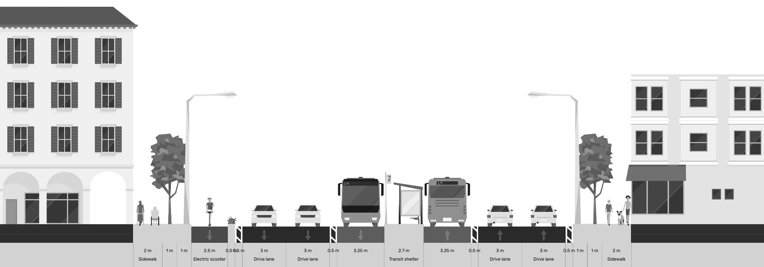

Conceptual Design and Due Diligence for the Yerevan Sustainable Urban Transport and Electric Mobility

Part of Output 8: Traffic and Parking Surveys and Analysis Report

September 30, 2026
Table of Contents
1 Executive Summary 6
2 Introduction 6
2.1 Purpose and Scope 6
2.2 Relationship to the Terms of Reference 6
3 Survey Methodology 7
3.1 Evolution of the Survey Approach 7
3.2 Adopted Methodology: Desk-Based Supply Inventory 7
3.3 Survey Instructions and Quality Control 8
3.4 Data Sources 8
4 Parking Supply Inventory Results 8
4.1 Aggregate Supply Summary 8
4.2 On-Street Parking by Regulatory Zone 9
4.3 On-Street Parking by Configuration 10
4.4 Signage 12
4.5 Marking 12
4.6 Corridor 1: Street-Level Detail 14
4.7 Corridor 2: Street-Level Detail 15
5 Parking Impacts of the Conceptual Corridor Designs 16
5.1 Nature of the Impact 16
5.2 Scale of Parking Removal 17
5.3 Impact by Sensitivity Zone 18
6 Field Occupancy Survey: Methodology, Locations and Results 19
6.1 Survey Design and Instrument 19
6.2 Where and When the Surveys Were Conducted 20
6.3 Occupancy Results by Area 21
6.4 Duration of Stay and Turnover 23
7 Displacement Assessment 24
7.1 Understanding Displacement 24
7.2 Measured Displacement by Area 24
7.3 Available Absorptive Capacity 25
8 Conclusions 27

List of Figures
Figure 1 - On-corridor on-street supply by regulatory zone 9
Figure 2 - Location of on-corridor on-street parking by regulatory zone 9
Figure 3 - On-corridor on-street supply by marked configuration 10
Figure 4 - Location of on-corridor on-street parking by configuration 11
Figure 5 - On-corridor on-street supply by physical location 11
Figure 6 - Parking signage coverage 12
Figure 7 - Location of parking signage 12
Figure 8 - Pavement marking coverage 13
Figure 9 - Location of pavement marking 13
Figure 10 - Corridor 1: on-street parking by location, with off-street lots 15
Figure 11 - Corridor 2: on-street parking by location, with off-street lots 16
Figure 12 - Parking removed as a share of the impact area 17
Figure 13 - On-corridor parking retained and removed in the conceptual design 17
Figure 14 - Location of the six field survey areas 20
Figure 15 - Peak-hour occupancy by surveyed area 21
Figure 16 - Average daily occupancy by zone in the six survey areas 21
Figure 17 - Vehicles present by clock hour, all six areas combined 22
Figure 18 - Duration of stay by area 23
Figure 19 - Turnover by area 23
Figure 20 - Parking removed and demand displaced, by area 24
Figure 21 - Available absorptive capacity (off-street) 25
Figure 22 - Available absorptive capacity (on-street) 26

List of TABLES
Table 1 - # of Parking Spaces 8
Table 2 - On-Street Parking by Regulatory Zone 9
Table 3 - On-Street Parking by Configuration 10
Table 4 - On-Street Parking by Location 11
Table 5 - Corridor 1: Street-Level Detail 14
Table 6 - Corridor 2: Street-Level Detail 15
Table 7 - Impact by Sensitivity Zone 18
Table 8 - Surveyed zones by area: capacity, average occupancy and turnover 19
Table 9 - Field occupancy survey: areas, dates and footprint 20
Table 10 - Occupancy, stay and turnover by surveyed area 22
Table 11 - Measured displacement and absorption by area 24

PROJECT SYNOPSIS

Project Name | TA-6559 REG: Implementing the Cities Development Initiative for Asia - Conceptual Design and Due Diligence for the Yerevan Sustainable Urban Transport and Electric Mobility Project (54128-001)
Country | Republic of Armenia
Geographic Area | City of Yerevan
Contract Number | S208439
Contracting Authority | Asian Development Bank (ADB)
Signed on | 26 August 2025
Commencement of service | 11 September 2025
Duration | 12 calendar months
End Date | 7 August 2026
CLient / EA | The Executing Agency (EA) is the Yerevan Municipality (YM)
PIU | The Yerevan Urban Development Programs Implementation Unit (PIU)
Funding Source | Cities Development Initiative for Asia Trust Fund, administered by ADB, through TA 6559-REG: Implementing the Cities Development Initiative for Asia approved on 8 September 2020.
Scope of Work | To develop: (i) bus public transport service Plan for Yerevan; (ii) Conceptual Design of bus priority corridors; (iii) Upgraded depots to accommodate a fleet of battery electric buses; (iv) Traffic and Parking Management Plan; (v) Communications and Branding; and (vi) due diligence for ADB’s consideration of project financing.
Key Deliverables | Inception Report (followed by inception workshop)  Output 1: Memo describing selection of affected routes for further analysis  Output 2: Data collection methodology memo  Output 3: Raw and processed datasets for all collected data (Excel), including maps  Output 4: Network diagnostics PPT  Output 5: Service Plan PowerPoint and report, including high-quality, graphic-designed maps of the network, each route, and changes to existing routes  Output 6: Full conceptual-level designs for the bus priority corridors, bus stations, off-corridor stops, utilities, ITS, points along the off-corridor routes, and costings  Output 7: 3-D renderings of stations, with three different top structure architectural designs  Output 8: Traffic and parking surveys and analysis report  Output 9: Traffic Management Plan, including microsimulation  Output 10: Parking analysis report  Output 11: Report reviewing existing conditions at depots and future plans  Output 12: Conceptual design for both depots  Output 13: PPTs, handouts, and minutes from three public workshops  Output 14: Communication Strategy  Output 15: System brand including name and logo  Output 16: Stakeholder engagement plan  Output 17: IEE/EIA  Output 18: LARP  Output 19: Financial Management Assessment Report  Output 20: Financial Analysis Report and Linked Document  Output 21: Economic Analysis Report and Linked Document  Output 22: Strategic Procurement Plan  Output 23: Terms of reference  Output 24: Climate Risk and Adaptation Assessment  Output 25: Climate Change Assessment  Output 26: Poverty, Social and Gender Assessment Report  Output 27: Social Development and Gender Action Plan  Output 28: Institutional Assessment  Output 29: Institutional and Capacity Building Roadmap Output 30: Report on Knowledge Transfer Activities.
Consultant / Contractor | A+S Consult GmbH, Logit Consulting Inc, Exponent Engineers (Pvt.) Limited & POGHOS SHAHINYAN HAYKAZI
Contact | Team Leader: Wagner Colombini Martins, wagner.colombini@logiteng.com  Focal point: Lívia Delgado Rodrigues, livia.delgado@logiteng.com

Executive Summary
The Yerevan Sustainable Urban Transport and Electric Mobility Project is being prepared with support from the Asian Development Bank (ADB) through the Cities Development Initiative for Asia (CDIA). The project focuses on improving urban mobility through the introduction of bus priority corridors totalling 30 kilometres, upgrading two trolleybus depots for 249 battery-electric buses, and implementing complementary traffic and parking management measures.
The bus priority corridors are: Corridor 1 (11.66 km) starts near Bagratunyats (south) and runs northeast to Kentron; Corridor 2 (19.19 km) starts at Nor Nork (east) and runs west to Davtashen. The conceptual designs involve the reallocation of street space, including dedicated bus lanes, improved pedestrian and non-motorised transport facilities, upgraded intersections, and public-realm improvements.

Introduction

Purpose and Scope
This report constitutes the parking component of the Traffic and Parking Surveys and Analysis Report (Output 8). It documents the parking supply surveys conducted along and adjacent to the bus priority corridors, presents the findings of the desk-based inventory and assesses the impacts of the conceptual corridor designs on parking.
The report should be read in conjunction with the standalone Parking Analysis Report (Output 10), which provides current context for parking management in Yerevan and provides potential mitigation measures for the displacement of parking places along the corridors.
This revision incorporates the results of a targeted field occupancy survey carried out after the desk-based inventory, on six representative areas. The deliverable therefore now presents both supply-side evidence (the inventory) and measured demand-side evidence (occupancy, duration, turnover and locally-measured displacement).

Relationship to the Terms of Reference
The ToR (Task 3, paragraphs 59–63) requires the Consultant to conduct a Parking Supply Survey documenting all on-street parking spaces and curb regulations along the bus priority corridors and for approximately 100 metres on every cross street, as well as all off-street parking spaces within a 100-metre radius of the corridors. The ToR further requires a Parking Occupancy Survey recording the number of parked vehicles at each hour, classified by vehicle type, to estimate turnover rates.
Following technical review and stakeholder discussions, the survey methodology was refined to prioritise a comprehensive desk-based parking supply inventory, supplemented by targeted demand analysis using municipal ANPR data where available. The justification for this methodological adjustment has been formally communicated to ADB and the PIU, and is summarised in Chapter 3 of this report.
The occupancy and duration component of the ToR, initially descoped on proportionality grounds, has subsequently been satisfied in representative form through this targeted field survey. The deliverable therefore meets the intent of the ToR rather than departing from it.

Survey Methodology

Evolution of the Survey Approach
The initial survey methodology envisaged a full-scale, corridor-wide field survey to document parking supply and occupancy patterns, including 17-hour observation windows, manual licence plate recording, and systematic logging of illegal parking. Following multiple rounds of technical discussions, iterative revisions of the methodology paper, and detailed review of implementation requirements, it became evident that such a comprehensive field operation would be both resource-intensive and disproportionate to the analytical needs of the assignment.
The primary purpose of this project is to support the design and implementation of bus priority infrastructure, which will significantly alter or in many cases fully remove existing on-street parking along the corridors. Under such conditions, detailed temporal parking characteristics (hourly occupancy profiles, turnover rates, duration patterns) have limited relevance, as the baseline parking situation will not be retained. The key planning challenge is not to optimise existing parking performance, but to understand the spatial distribution of parking supply and assess how displaced demand can be accommodated.
This position was subsequently revised. Rather than forgo occupancy evidence entirely, a proportionate field occupancy survey - six representative areas rather than the full 34 km - was conducted in late May and early June 2026, restoring the occupancy, duration and turnover evidence that the corridor design and the displacement assessment require. The areas were surveyed on four separate ordinary working days (Komitas, Friday 29 May; Shiraz/Hasratyan, Monday 1 June; Garegin Nzhdeh and Gai Avenue, Tuesday 2 June; Kentron and Malatia-Sebastia, Wednesday 3 June), with no weekend or public holiday; because the areas were spread across separate days rather than surveyed simultaneously, a one-off disruption would show as a localised outlier, whereas the behavioural patterns repeat across all six.

Adopted Methodology: Desk-Based Supply Inventory
The project team adopted a supply-led and spatially targeted analytical framework comprising three components:
Component 1: Desk-Based Parking Supply Inventory. A comprehensive spatial inventory of all on-street and off-street parking along and adjacent to corridors, developed using high-resolution digital tools including 360-degree street videos collected during project field missions (accessible at yerevan.omni7.app), recent Google Earth satellite imagery, and Yandex Maps street-level views. Two local surveyors were deployed remotely to systematically map and geo-reference every parking segment along the corridors and within the 100-metre cross-street influence area.
Component 2: Field Occupancy Survey (targeted). Hourly licence-plate sweeps from 07:00 to 24:00 across the six representative areas, recording for every parked vehicle the time, zone, plate, vehicle type, kerb location, parking method and legality. This provides the demand-side evidence - occupancy, duration and turnover - directly. (The municipal ANPR system maintained by Parking City Service CJSC remains available to the city for ongoing monitoring, but is not relied upon for the demand analysis in this report.)
Component 3: Targeted Field Verification. Quality assurance included a random cross-check of approximately 15% of the total surveyed parking spaces, with consultant staff independently verifying results against the video footage collected during the survey campaign. In addition, local staff conducted several on-the-spot field visits to selected locations to validate desk-based findings against real-time conditions on the ground.

Survey Instructions and Quality Control
Detailed survey instructions were prepared and distributed to the two local surveyors. The instructions specified the following protocols:
On-street parking (linear data): Surveyors created georeferenced paths in Google Earth for each parking segment. For parallel parking, capacity was calculated using the formula: Spaces = Length / 7.5 metres. For perpendicular (90°) and echelon (45°) parking, actual visible spots or parked cars were counted. Each segment was attributed with: number of spaces, parking angle (parallel/90/45), presence of signage (Yes/No), presence of marking (Yes/No), and location type (on-street/pocket/set-back).
Regulatory classification: Segments were colour-coded according to parking regulation status: Red for Zone A (paid), Blue for Zone B (paid), Yellow for no-parking/illegal zones (where vehicles park despite prohibition), and White for free parking. Segments were named using a standardised coding convention (e.g., Gai001, Gai002 for sequential legal segments on Gai Street).
Off-street parking (polygon data): Off-street facilities were mapped using polygon tools in Google Earth, with capacity estimated using the formula: Spaces = Total Area (sqm) / 30. Only publicly accessible parking was recorded; private fenced lots such as those for “employees only” were excluded.

Data Sources
- 360-degree street video footage from project field missions (yerevan.omni7.app)
- Google Earth satellite imagery and the project GIS layer (shared KML project file)
- Yandex Maps street-level imagery for verification of parking conditions, signage, and road markings

Parking Supply Inventory Results

The complete results of the desk-based parking supply inventory are presented on the interactive web platform at https://yerevan-parking.vercel.app and are derived from the GeoJSON dataset containing geo-referenced features. The key summary findings are presented below.

Aggregate Supply Summary
The survey documented a total of 14,587 parking spaces across Corridors 1 and 2 and their 100-metre influence areas, comprising 7,825 on-street spaces and 6,762 off-street spaces.

Table 1 - # of Parking Spaces
Parameter | On-Street | Off-Street | Total
Total spaces | 7,825 | 6,762 | 14,587
Corridor 1 | 2,349 | -
Corridor 2 | 3,746
Cross-streets | 1,730 |  | 1,730
Yards |  | 6,762 | 6,762

*Below sub-chapters provide information about parking spaces strictly on the corridor space without accounting for the 100-m “buffer” territory.*

On-Street Parking by Regulatory Zone
Of the 6,095 on-street spaces surveyed along the corridors, the vast majority (5,248 spaces, 86.1%) have no payment zone classification, reflecting the predominance of free parking in the city. Only 780 spaces (12.8%) are within the paid parking system managed by Parking City Service CJSC. An additional 67 spaces (1.1%) were identified as specialized locations for taxi drivers.
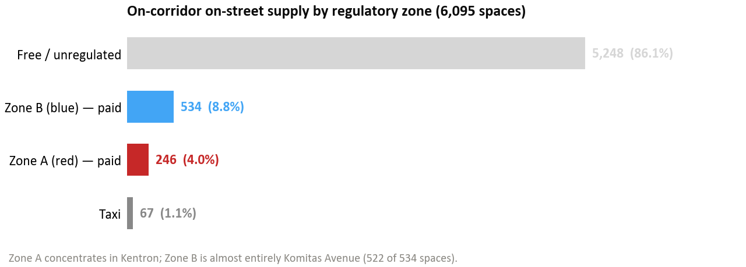
Figure 1 - On-corridor on-street supply by regulatory zone
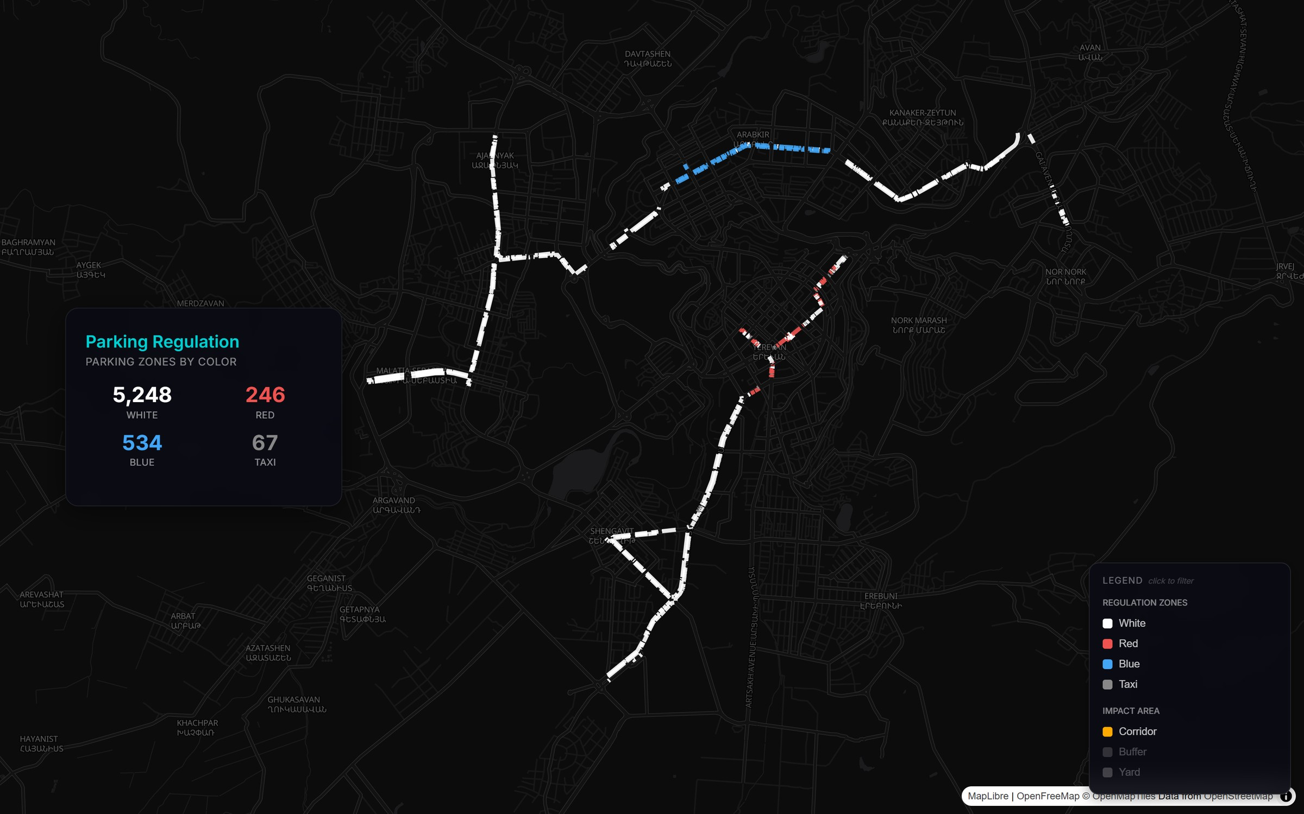
Figure 2 - Location of on-corridor on-street parking by regulatory zone

Table 2 - On-Street Parking by Regulatory Zone
Zone Classification | Spaces | Share of Total
Zone A (Red) – paid | 246 | 4.0%
Zone B (Blue) – paid | 534 | 8.8%
Taxi | 67 | 1.1%
Free | 5,248 | 86.1%
Total | 6,095 | 100%

Zone A spaces are concentrated in the Kentron district along Corridor 1, primarily on Nalbandyan (69 spaces), Tigran Mets (47), Abovyan (46), Amiryan (43), Agatangeghos (21) and Moskovyan (20). Zone B spaces are almost entirely on Komitas Avenue (522 of the 534 Zone B spaces) along Corridor 2, with a small remainder on Vagharshyan (12).

On-Street Parking by Configuration
Table 3 - On-Street Parking by Configuration
Parking Method | Spaces | Share
Parallel | 4,655 | 76.4%
Perpendicular (90°) | 1,440 | 23.6%
Total | 6,095 | 100%

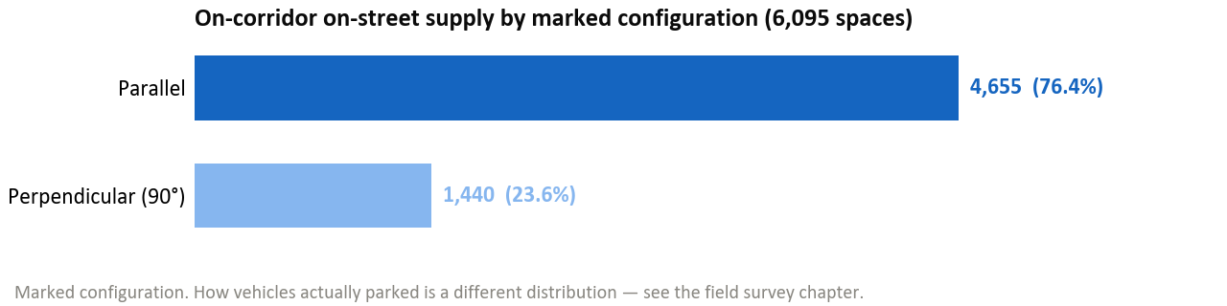
Figure 3 - On-corridor on-street supply by marked configuration
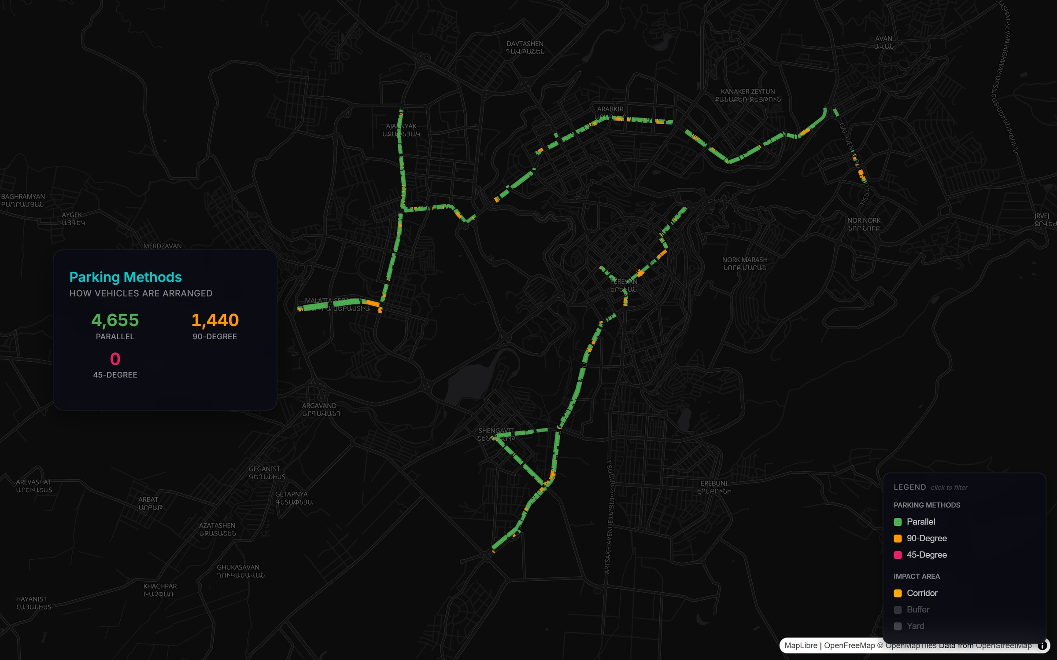
Figure 4 - Location of on-corridor on-street parking by configuration

Table 4 - On-Street Parking by Location
Location Type | Spaces | Share
On-street (road edge) | 4,394 | 72.1%
Pocket (inset into curb) | 1,431 | 23.5%
Set-back (separated from road) | 270 | 4.4%
Total | 6,095 | 100%

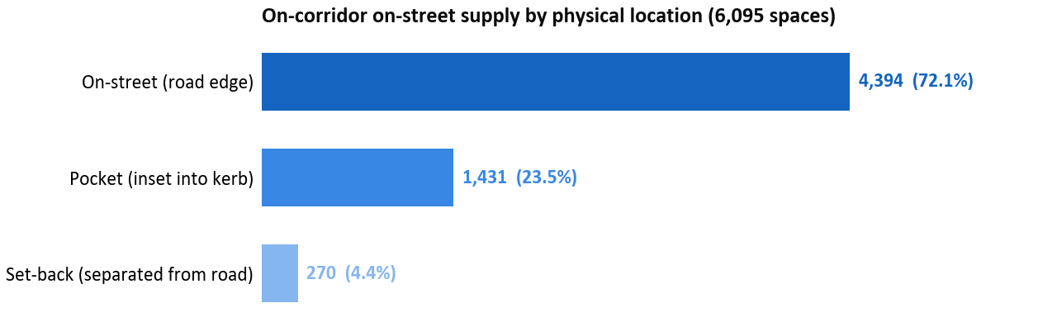
Figure 5 - On-corridor on-street supply by physical location

Signage
Only 1,201 of the 6,095 on-street spaces (19.7%) have visible parking signage. The remaining 4,894 spaces (80.3%) lack formal signage, confirming that the vast majority of parking along the corridors operates without clear regulatory indication to drivers.
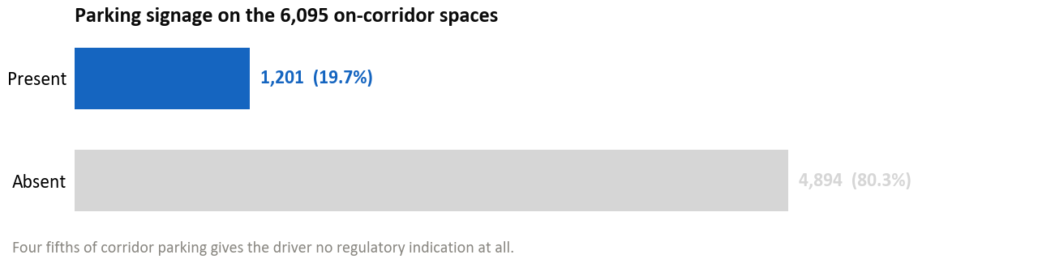
Figure 6 - Parking signage coverage
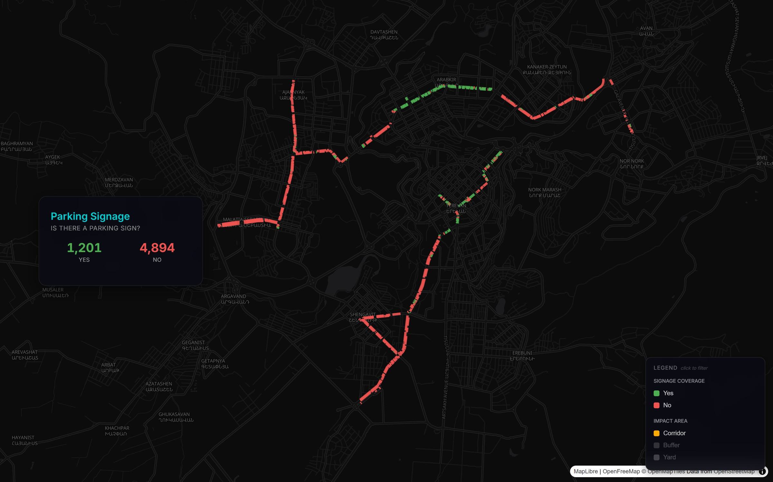
Figure 7 - Location of parking signage

Marking
Only 856 of the 6,095 on-street spaces (14.0%) have visible parking markings on the pavement. The remaining 5,239 spaces (86.0%) lack formal marking.
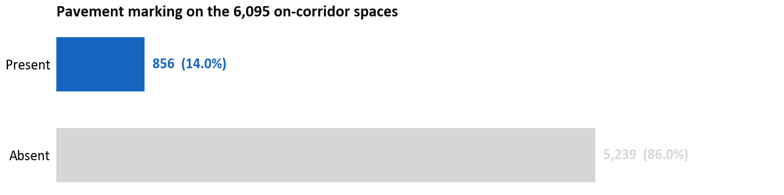
Figure 8 - Pavement marking coverage
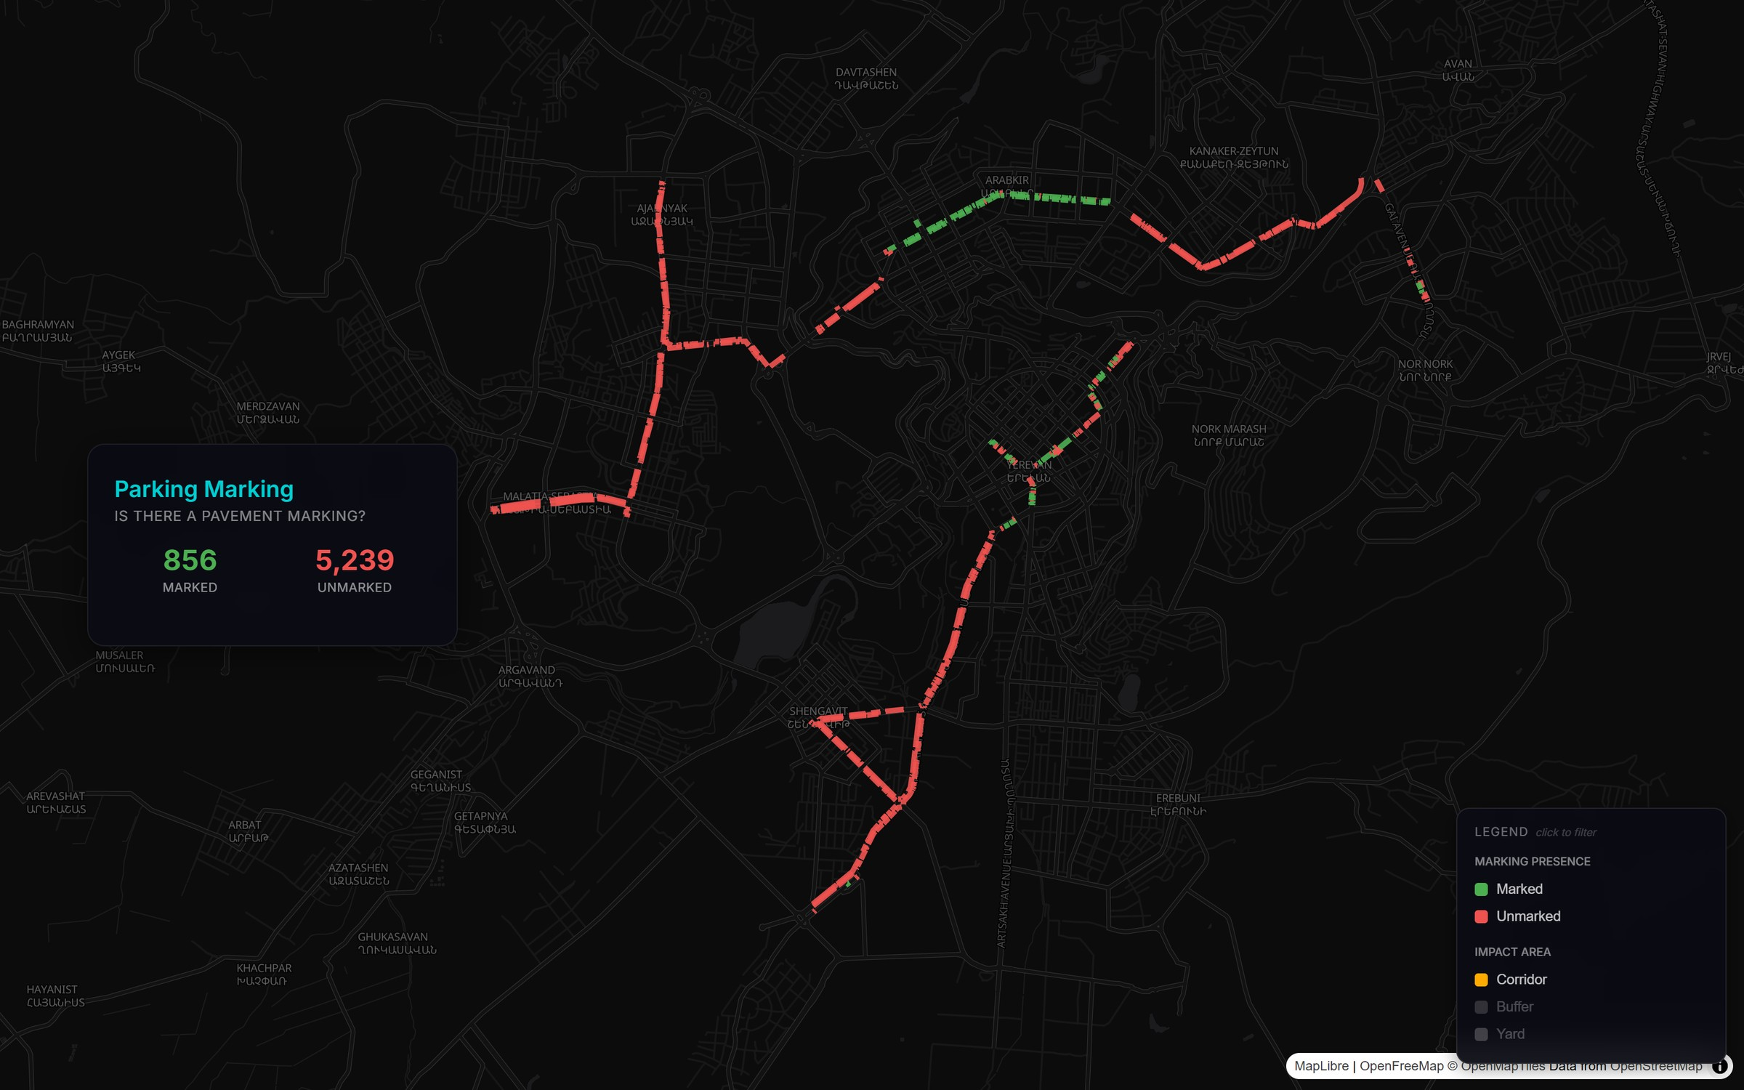
Figure 9 - Location of pavement marking

Corridor 1: Street-Level Detail
Corridor 1 (11.66 km) accounts for 2,349 on-corridor on-street spaces, a further 489 on-street spaces on cross-streets within the 100-metre influence area, and 3,040 off-street spaces in 83 facilities - 5,878 spaces in total within the survey area.
Table 5 - Corridor 1: Street-Level Detail
Street | On-Street Spaces
Arshakunyats Avenue | 1,181
Bagratunyats | 331
Nalbandyan | 252
Garegin Nzhdeh | 171
Abovyan | 154
Amiryan | 84
Tigran Mets | 76
Moskovyan | 46
Agatangeghos | 30
Arshakunyats 1st | 24
Total | 2,349

Major off-street facilities along the Corridor 1 include the Yerevan Mall area (145 spaces), the Arshakunyats Tonavachar complex (107 spaces), the Agatangeghos Ayrarat facility (92 spaces), and numerous residential yard areas.

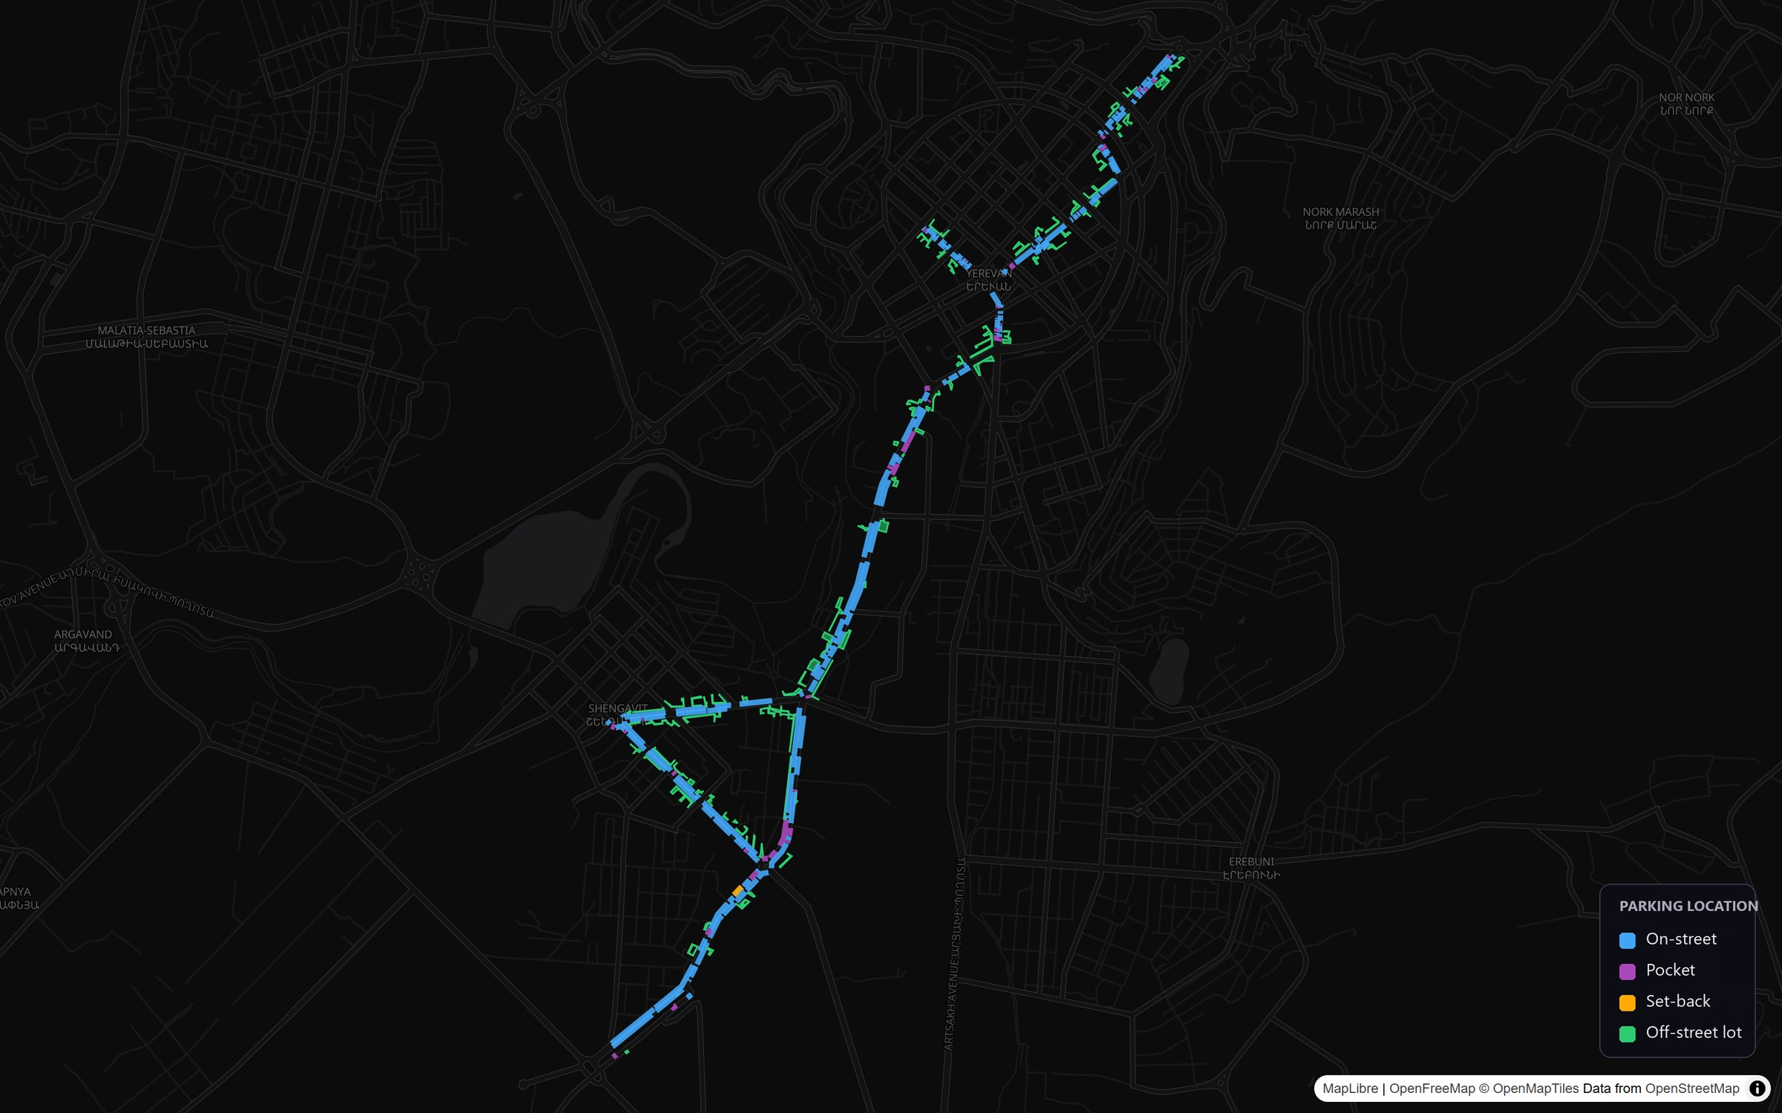
Figure 10 - Corridor 1: on-street parking by location, with off-street lots

Corridor 2: Street-Level Detail
Corridor 2 (19.19 km) accounts for 3,746 on-corridor on-street spaces, a further 1,241 on-street spaces on cross-streets within the 100-metre influence area, and 3,692 off-street spaces in 156 facilities - 8,679 spaces in total within the survey area.
Table 6 - Corridor 2: Street-Level Detail
Street | On-Street Spaces
Raffi | 766
Komitas Avenue | 539
Rubinyan | 517
Sebastia | 461
Qrq Qrqoryan | 298
Grigor Hasratyan | 276
Davit Anhaght | 274
Kievyan | 219
Shiraz | 168
Gai | 157
Vazgen Sargsyan (City) | 30
Vazgen Sargsyan / Mher Mkrtchyan Sq. | 17
Vagharshyan | 12
Barekamutyun | 6
Kievyan 1st | 6
Total | 3,746

Major off-street facilities along the Corridor 2 include the Zeytun City complex (145 spaces), the Komitas City facility (123 spaces), and numerous residential yard areas throughout the Sebastia, Komitas, and Kievyan segments.

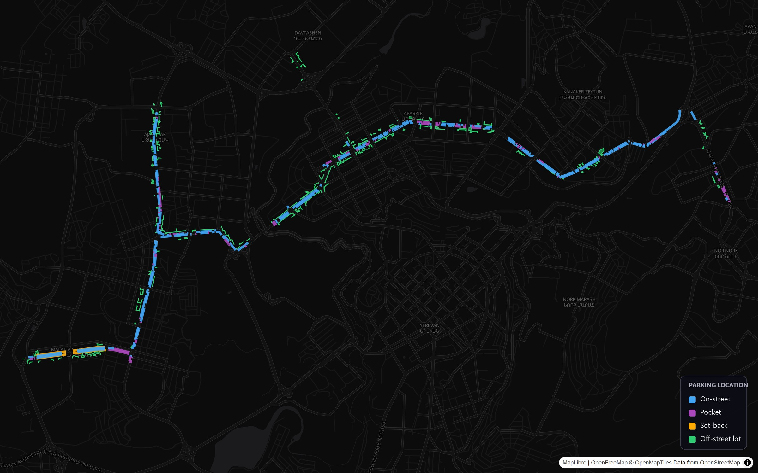
Figure 11 - Corridor 2: on-street parking by location, with off-street lots

Parking Impacts of the Conceptual Corridor Designs

Nature of the Impact
The conceptual corridor designs reallocate the whole cross-section. Along much of the alignment the dedicated bus lanes run in the central median; along other sections they run kerbside. That distinction matters for where passengers board - an island platform in the carriageway rather than a stop on the footway - but it does not drive the parking impact. A kerb-aligned bus lane occupies the very kerbside space that parking occupies, and so removes as much on-street parking as a median-aligned one; in station areas it removes slightly more. The parking loss follows from reallocating the full right-of-way to bus lanes, general traffic, cycle lanes and adequate footways, not from the choice of alignment. Between stations, however, the cross-section is less demanding, and in most such sections there is room for parking to remain. That is why the design retains or re-establishes 1,220 spaces.

Scale of Parking Removal
The bus priority corridors remove 4,875 of the 6,095 on-corridor on-street spaces and retain or re-establish 1,220. Corridor 1 loses 1,480 of 2,349 spaces, retaining 869; Corridor 2 loses 3,395 of 3,746, retaining 351. Measured against the impact area, those 4,875 spaces are 62% of the 7,825 on-street spaces within the corridors and their 100-metre influence area, and 33% of all 14,587 spaces once the 6,762 off-street spaces are counted. The first figure counts on-street supply only; the second includes off-street.

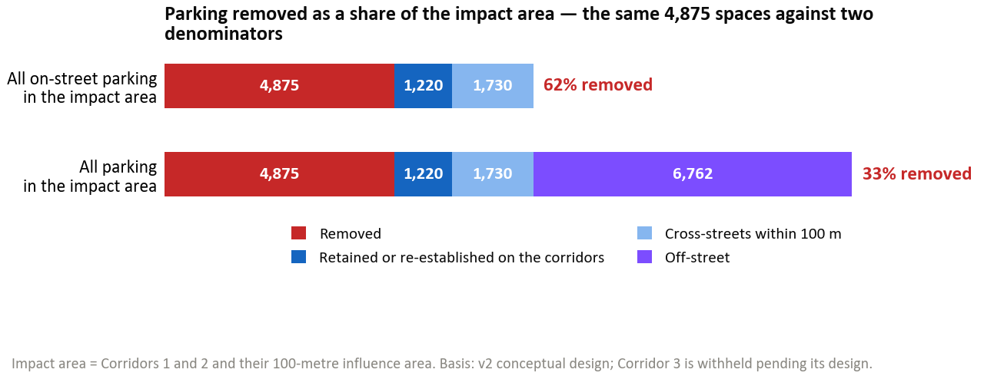
Figure 12 - Parking removed as a share of the impact area
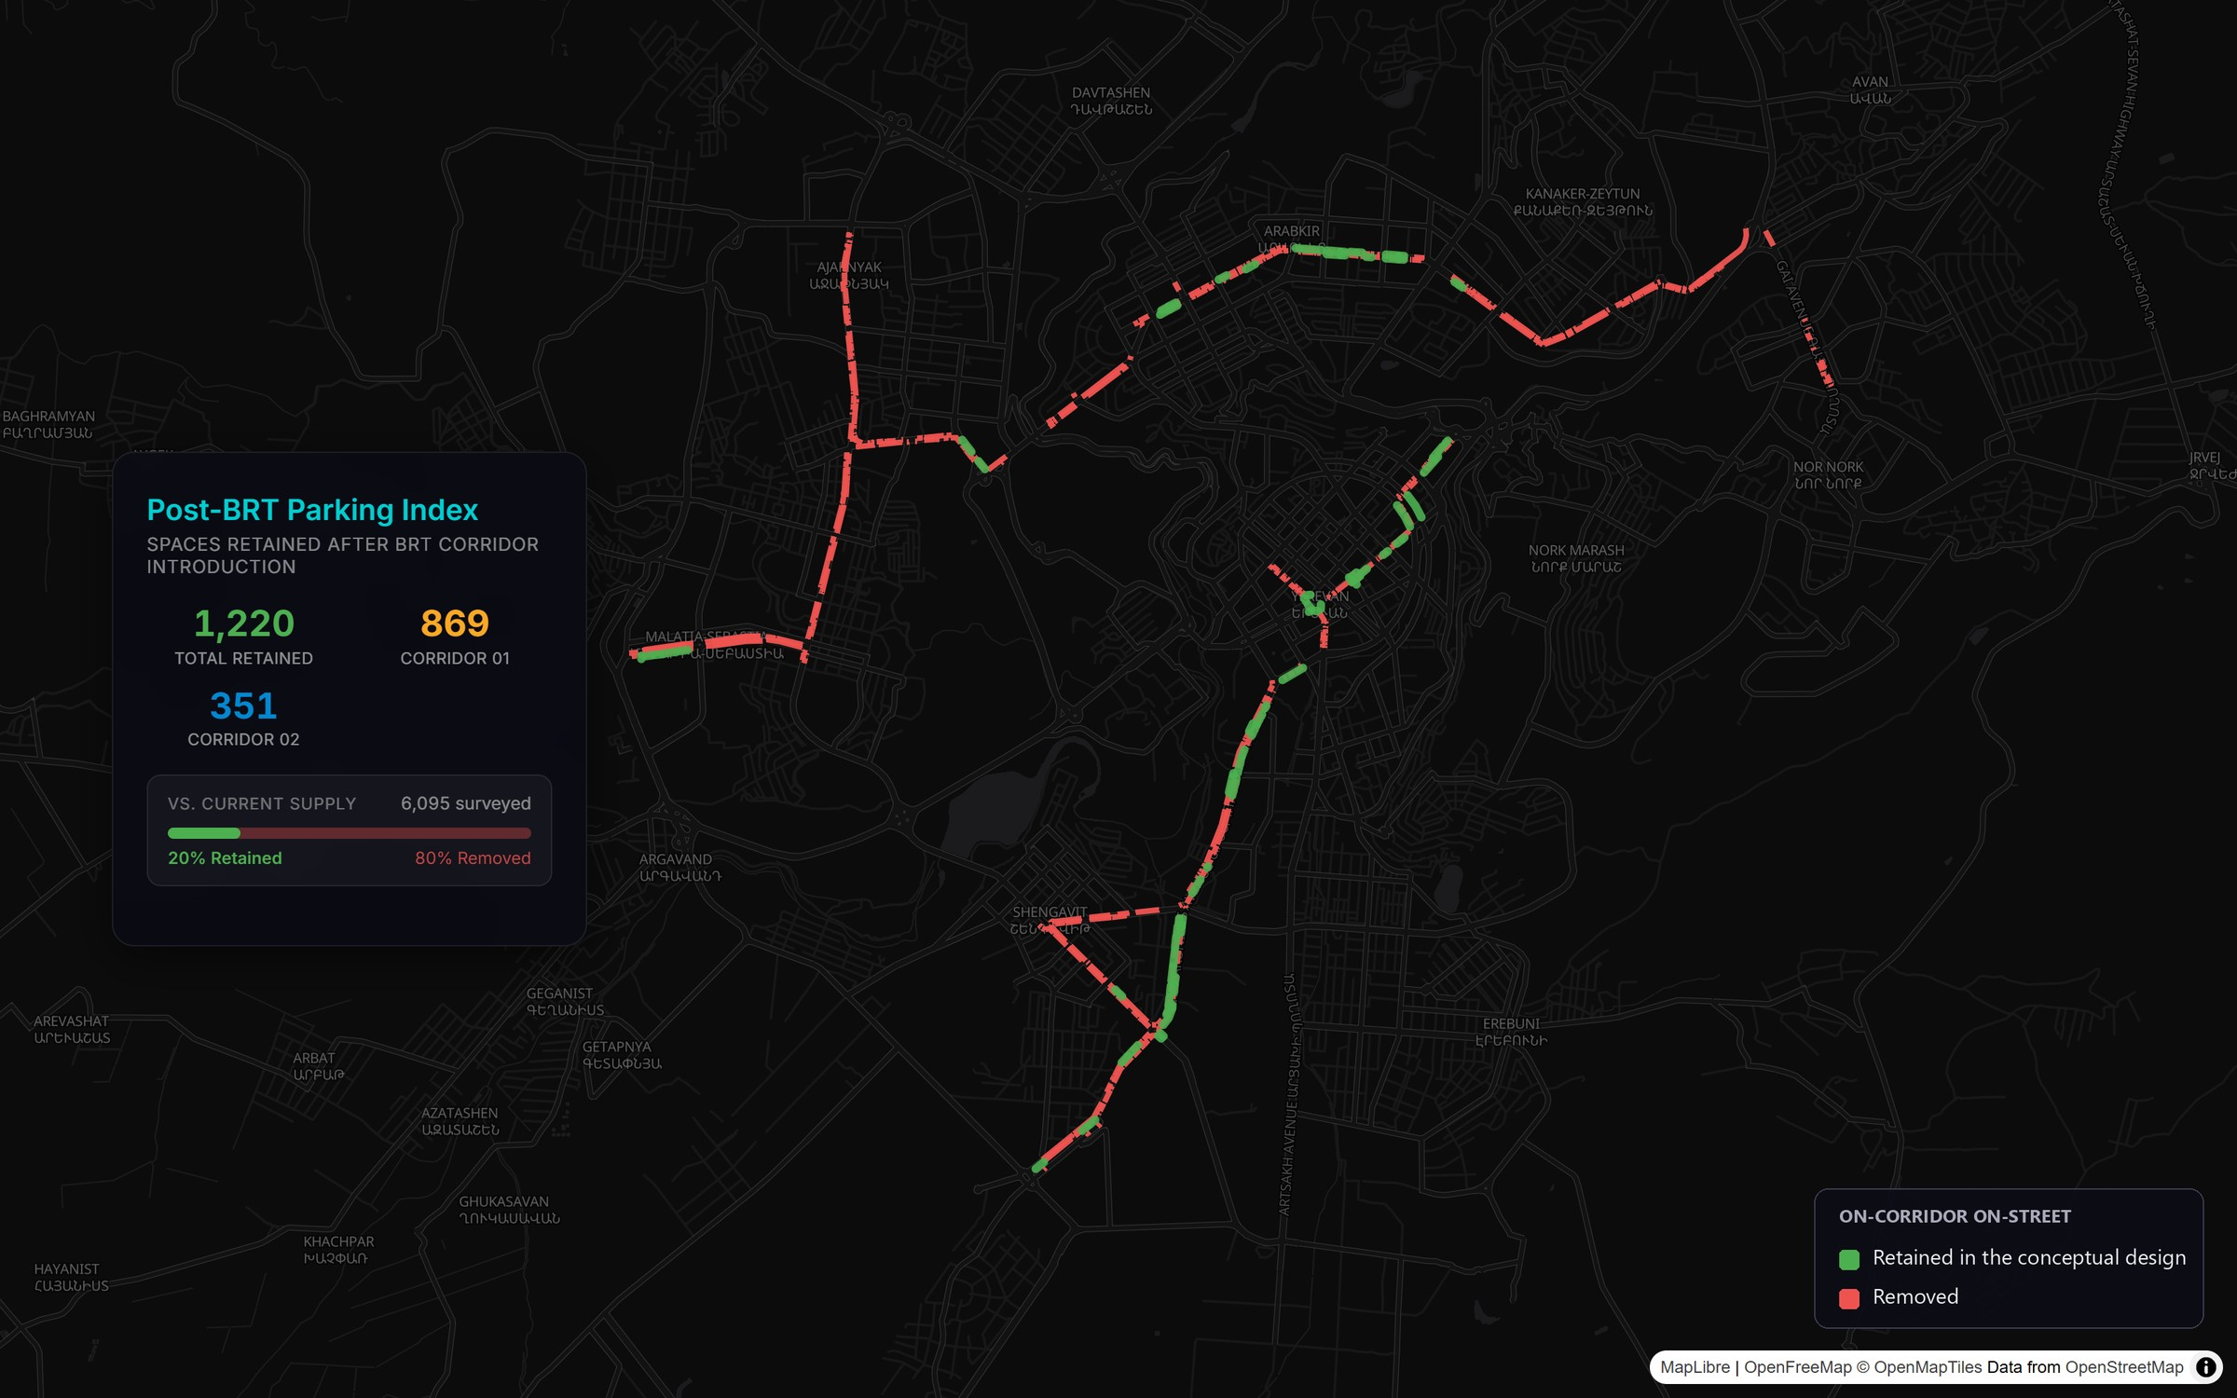
Figure 13 - On-corridor parking retained and removed in the conceptual design

Impact by Sensitivity Zone
Table 7 - Impact by Sensitivity Zone
Sensitivity | Corridor Segments | On-Street Spaces | Key Concern
High | Komitas Avenue (539), Nalbandyan (252), Abovyan (154), Amiryan (84), Tigran Mets (76) and 2 further streets | 1,181 | Zone A and Zone B pricing; limited side-street capacity; competing commercial demands. Field survey: Kentron 89% at its busiest hour with only 10% absorbable on-street; Komitas 83% with 0% on-street absorption - Komitas is reclassified from medium to high on this evidence.
Medium | Arshakunyats Avenue (1,181), Davit Anhaght (274), Kievyan (219), Garegin Nzhdeh (171) and 2 further streets | 1,875 | Mixed residential, commercial and arterial functions; some absorptive capacity on parallel streets. Field survey: Garegin Nzhdeh 63% at its busiest hour / 30% absorption.
Lower | Raffi (766), Rubinyan (517), Sebastia (461), Bagratunyats (331), Qrq Qrqoryan (298) and 7 further streets | 3,039 | Predominantly free and unmarked; suburban; more flexible accommodation. Field survey: Shiraz/Hasratyan 42% / 69%, Malatia-Sebastia 35% / 97% - confirmed lower.

Field Occupancy Survey: Methodology, Locations and Results
The demand-side evidence in this report comes from a targeted field occupancy survey carried out after the desk-based supply inventory. This chapter documents how it was designed, where it was conducted and what it measured, and then presents the results broken down by area. The aggregate headlines are that occupancy at the busiest hour is 61% across the six areas together, ranging from 35% in Malatia-Sebastia to 99% at Gai Avenue, and that the kerb is short-stay and high-turnover.

Survey Design and Instrument
The survey was a rolling licence-plate census rather than a spot count. Enumerators walked a fixed circuit of numbered survey zones - short segments of street, typically one block face - once an hour from 07:00 to 24:00, recording every parked vehicle on each pass. Recording the plate rather than only a headcount is what makes duration, turnover and displacement measurable: a plate seen in consecutive hours is one vehicle staying, whereas the same space occupied by successive plates is turnover, and a mere headcount cannot tell the two apart.
For every parked vehicle the enumerator recorded seven fields: the hour of observation; the survey zone; the licence plate; the vehicle type (sedan, truck or motorcycle); where the vehicle stood relative to the carriageway (on the carriageway, on the footpath, or in a setback); how it was parked (parallel, 45 degrees, or perpendicular); and whether the parking was legal or illegal.
Occupancy is measured against the capacity already recorded in the supply inventory - the number of vehicles a segment can hold - so the demand and supply sides share a single denominator. Where the inventory carries no figure for a segment, capacity is estimated at one vehicle per 7.5 metres of parallel kerb. A parking event, the unit behind turnover, is one continuous run of hours in which a plate is present; a gap of at least one hour is treated as the space having been vacated and re-used. In total the survey produced 21,186 on-street vehicle sightings covering 10,135 distinct vehicles across 203 survey zones, plus one off-street facility in each of the six areas.
Table 8 - Surveyed zones by area: capacity, average occupancy and turnover
Area | Zones surveyed | Spaces | Average daily occupancy | Turnover per space/day
Kentron | 53 | 534 | 73% | 7.5
Komitas Avenue | 53 | 450 | 50% | 5.5
Gai Avenue (Mega Mall) | 10 | 132 | 73% | 6.6
Garegin Nzhdeh | 31 | 451 | 42% | 5.3
Shiraz / Hasratyan | 34 | 439 | 27% | 3.7
Malatia-Sebastia | 22 | 872 | 25% | 3.5
All six areas | 203 | 2,878 | 43% | 5.0
How occupancy is measured. Occupancy is the number of distinct vehicles that used a stretch of kerb during an hour, divided by the number of spaces on it. Each area is reported at its busiest hour. In Kentron, for example, 473 vehicles used the 534 surveyed spaces in the 21:00 hour: 473 / 534 = 89%. Every area percentage in this chapter is calculated this way. The same calculation for a single zone uses that zone's own busiest hour, which shows which stretches of kerb are saturated; because those hours differ from zone to zone, zone figures cannot be added up into an area figure.
A zone can read above 100%. The count covers every vehicle that used the kerb during the hour, not how many stood there at one moment, so three cars using one space in turn read as 300%; the busiest zone in the survey reaches six times its capacity. An area could do the same, although none does: the highest is Gai Avenue at 99%.

Where and When the Surveys Were Conducted
Six areas were surveyed rather than the full length of the corridors. They were chosen to span the corridors' sensitivity range: a dense commercial core under paid regulation (Kentron), the city's largest Zone B concentration (Komitas Avenue), a retail-anchored destination (Gai Avenue near Mega Mall), a mixed residential and commercial location (Garegin Nzhdeh), and two outer residential areas (Shiraz/Hasratyan and Malatia-Sebastia). Between them, they cover the full range of regulatory status, land use, and kerb pressure found along the corridors, which is what the displacement assessment requires.
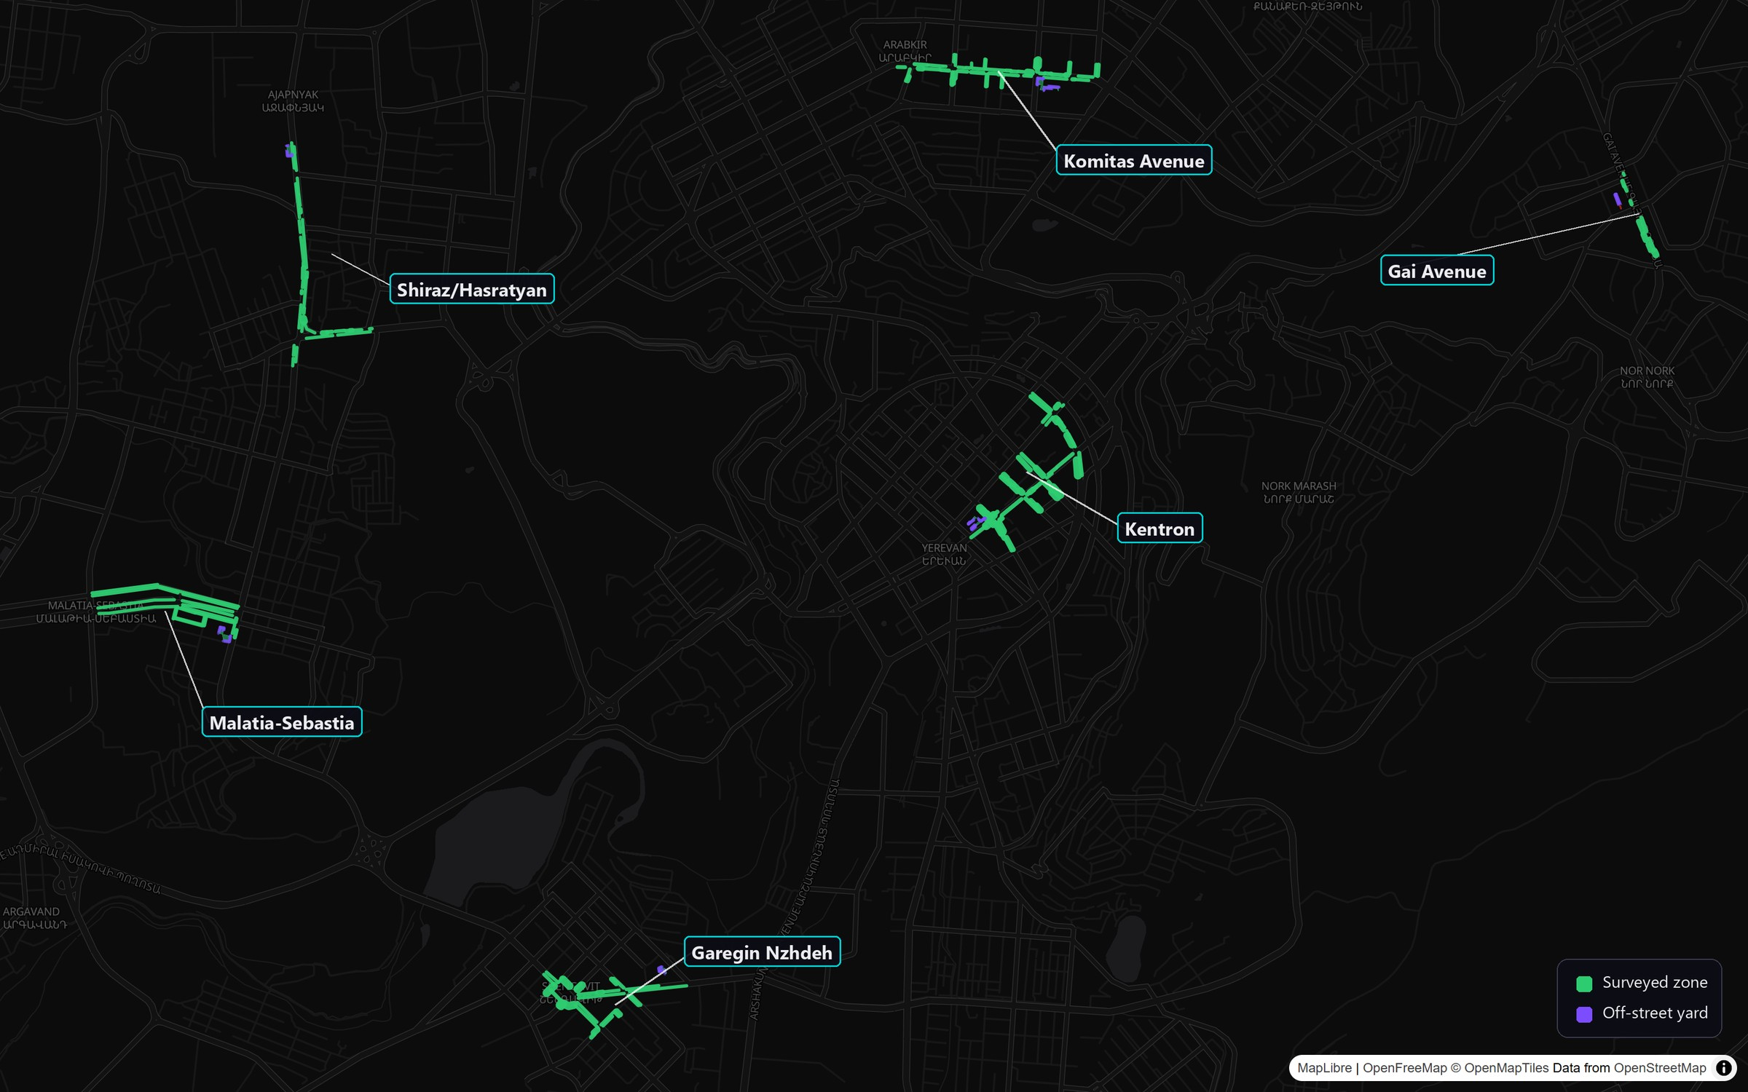
Figure 14 - Location of the six field survey areas
The areas were surveyed on four separate ordinary mid-week working days between 29 May and 3 June 2026, with no weekend or public holiday.

Table 9 - Field occupancy survey: areas, dates and footprint
Area | Survey date | Day | Formal spaces | Corridor
Kentron | 3 June 2026 | Wednesday | 586 | 1
Komitas Avenue | 29 May 2026 | Friday | 450 | 2
Gai Avenue (Mega Mall) | 2 June 2026 | Tuesday | 132 | 2
Garegin Nzhdeh | 2 June 2026 | Tuesday | 451 | 1
Shiraz / Hasratyan | 1 June 2026 | Monday | 439 | 2
Malatia-Sebastia | 3 June 2026 | Wednesday | 872 | 2
All six areas | 29 May to 3 June 2026 | 4 working days | 2,930 | 1 and 2

Occupancy Results by Area
Across the six areas together, 1,756 distinct vehicles used the kerb, each area counted at its own busiest hour - 61% of the 2,878 spaces in the zones where occupancy was recorded. That is 52 fewer than the 2,930 spaces in Table 9, because five Kentron zones were inventoried on the supply side but not swept for occupancy; they are excluded from every occupancy figure in this chapter, which is why Kentron is measured against 534 spaces rather than 586. The aggregate is not the operative number, because the six areas differ sharply. Gai Avenue is the most pressured at 99% at 13:00, with Kentron at 89% at 21:00 and Komitas at 83% at 15:00; Malatia-Sebastia reaches only 35% and Shiraz/Hasratyan 42%.

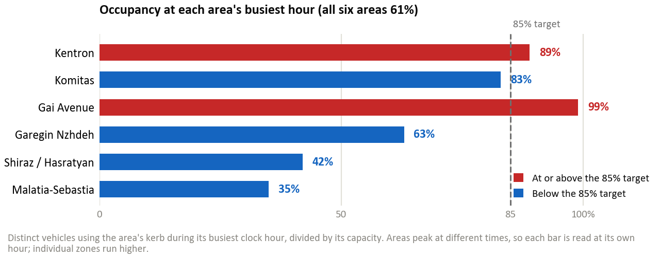
Figure 15 - Peak-hour occupancy by surveyed area
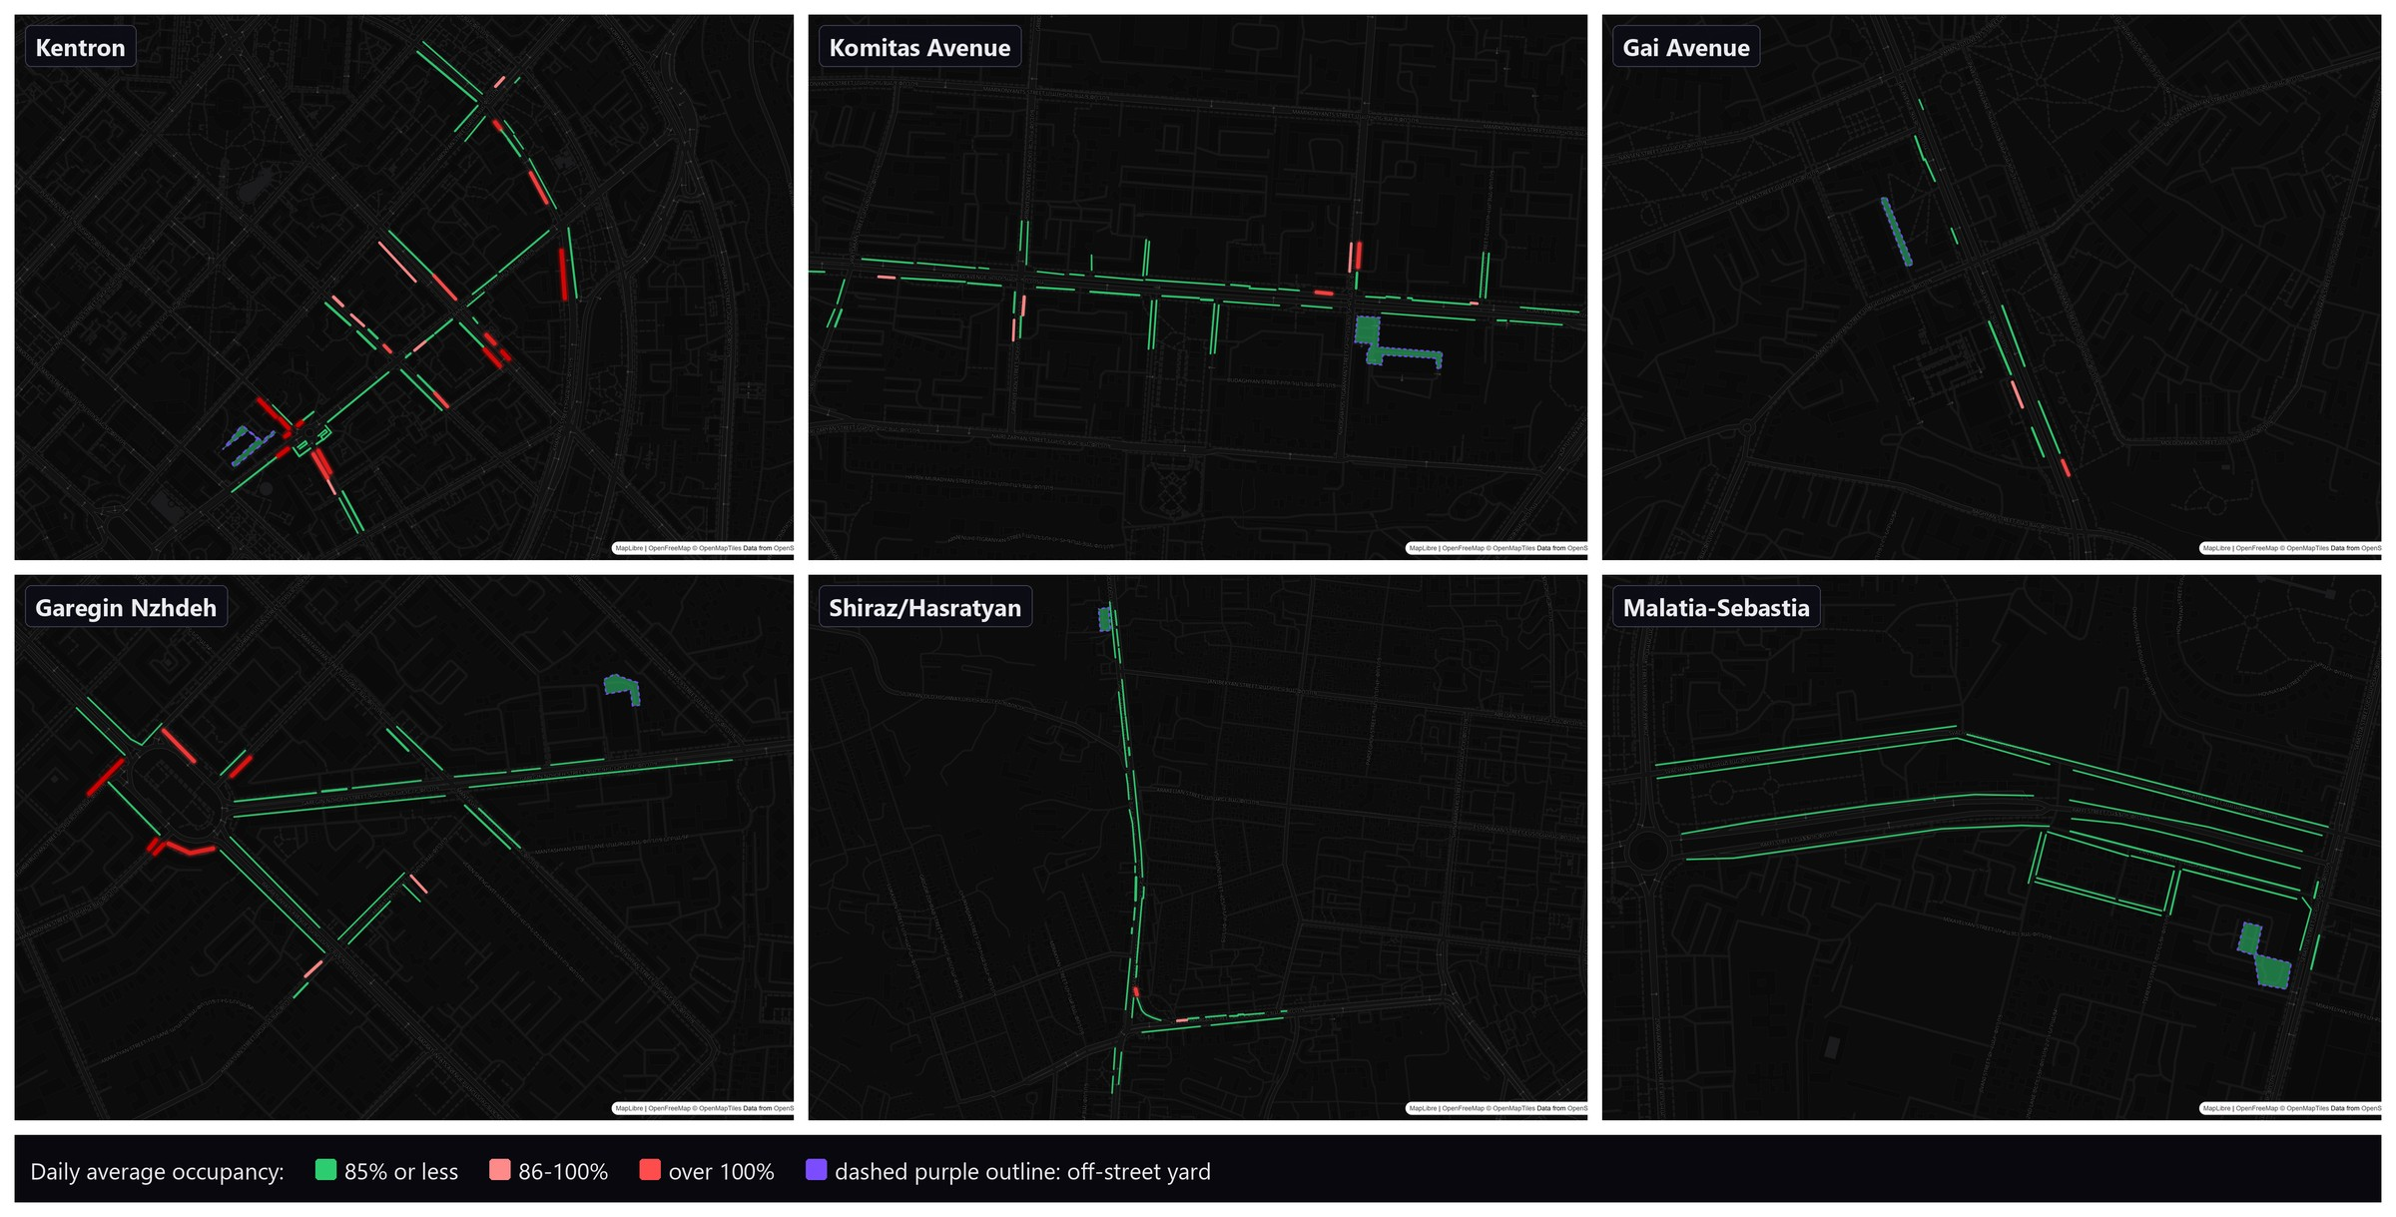
Figure 16 - Average daily occupancy by zone in the six survey areas

Table 10 - Occupancy, stay and turnover by surveyed area
Area | Peak-hour occupancy (area-wide) | Average stay | Turnover per space/day
Kentron (Corridor 1 core) | 89% at 21:00 | 2.2 h | 7.5
Komitas Avenue | 83% at 15:00 | 1.8 h | 5.5
Gai Avenue (Mega Mall) | 99% at 13:00 | 2 h | 6.6
Garegin Nzhdeh | 63% at 11:00 | 1.7 h | 5.3
Shiraz / Hasratyan | 42% at 13:00 | 1.6 h | 3.7
Malatia-Sebastia | 35% at 18:00 | 1.6 h | 3.5
All six areas | 61% (each area at its own hour) | 1.8 h | 3.5 to 7.5

The demand profile through the day explains why a single peak figure is adequate for the displacement assessment. Occupancy rises steeply from 07:00, plateaus across the working day, and holds late: the evening does not empty the kerb, because the residential and commercial peaks overlap rather than alternate. There is no quiet hour into which displaced demand could be shifted by timing measures alone.

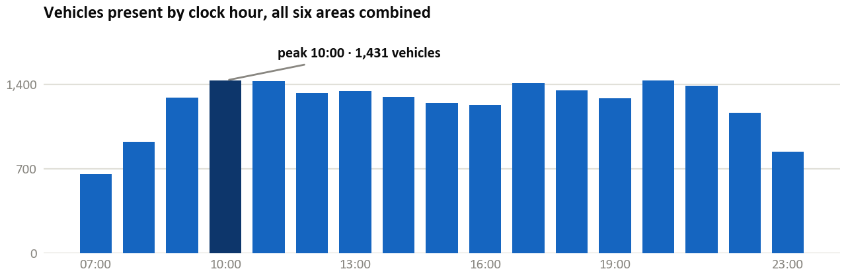
Figure 17 - Vehicles present by clock hour, all six areas combined

Duration of Stay and Turnover
The corridor kerb is dominated by short visits. About 63% of stays are one hour or less and 87% are two hours or less, while genuine all-day storage of eight hours or more is about 7% and the intermediate worker-length stay of two to eight hours about 6%. The average stay is 1.8 hours. This distribution is stable across all six areas, which is the strongest single behavioural finding of the survey: the kerb serves visitors and errands, not commuters.

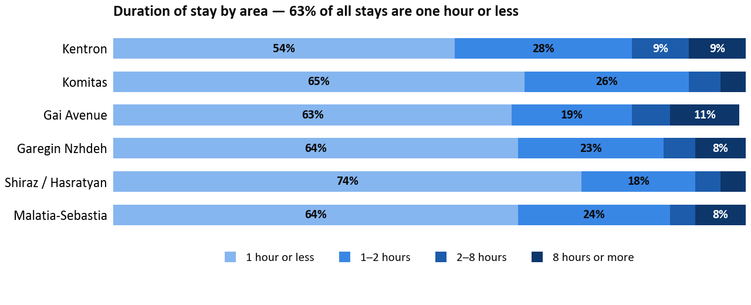
Figure 18 - Duration of stay by area

Turnover follows directly from the duration mix. Measured as parking events per space per day across all bay types, it runs from 3.5 in Malatia-Sebastia to 7.5 in Kentron, where the busiest kerb recycles each space between seven and eight times a day. The gradient tracks land use rather than regulation: the commercial core and the retail destination turn over fastest, the outer residential areas slowest, and the paid Zone B on Komitas sits between them at 5.5.

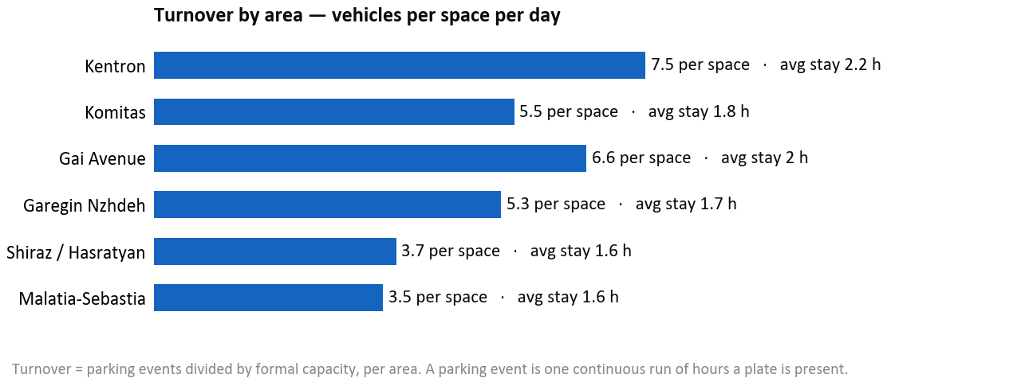
Figure 19 - Turnover by area

Displacement Assessment

Understanding Displacement
Parking displacement refers to the relocation of parking demand from the corridor to adjacent streets, off-street facilities, or alternative modes when on-street supply is removed. International experience with European BHLS corridors (Nantes, Metz, Rouen, Eindhoven, Helsingborg) consistently demonstrates that actual displaced demand requiring physical accommodation is typically lower than the number of spaces removed, due to modal shift, behavioural adaptation, and the elimination of informal parking.

Measured Displacement by Area
The conceptual design removes 1,886 spaces in the six surveyed areas, but displacement counts cars, not spaces: a removed space displaces a car only if one is parked there. At the busiest hour for the removed zones in each area, 1,123 vehicles were parked in them. That is the displaced demand the surrounding streets and off-street facilities must absorb. The other 763 removed spaces were empty at that hour, so their loss reduces supply but displaces no one. This does not mean that about 40% of the removed spaces are never used, only that they are not all occupied in the same hour.

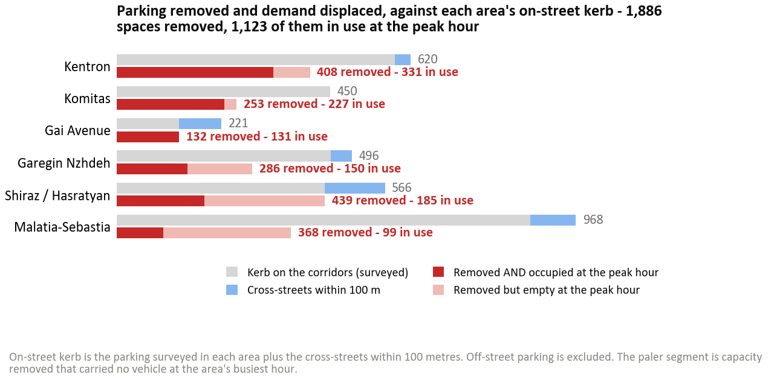
Figure 20 - Parking removed and demand displaced, by area

Table 11 - Measured displacement and absorption by area
Area | Spaces removed | Displaced at peak | Nearby on-street | Absorbed on-street | Nearby off-street
Kentron (Corridor 1 core) | 408 | 331 | 34 | 10% | 395
Komitas Avenue | 253 | 227 | 0 | 0% | 482
Gai Avenue (Mega Mall) | 132 | 131 | 89 | 68% | 27
Garegin Nzhdeh | 286 | 150 | 45 | 30% | 451
Shiraz / Hasratyan | 439 | 185 | 127 | 69% | 387
Malatia-Sebastia | 368 | 99 | 96 | 97% | 193
All six areas | 1,886 | 1,123 | 391 | 35% | 1,935

Available Absorptive Capacity
The survey identified substantial off-corridor capacity that can serve displaced demand if proper political will and administrative efforts are committed:
- 6,762 off-street spaces within the 100-metre influence area of Corridors 1 and 2. This stock is overwhelmingly gated residential courtyards rather than public parking: courtyards are 217 of the 239 facilities (91%) and 5,601 of the 6,762 spaces (83%); the balance is 22 named commercial and institutional lots, which are individually about twice the size of a courtyard
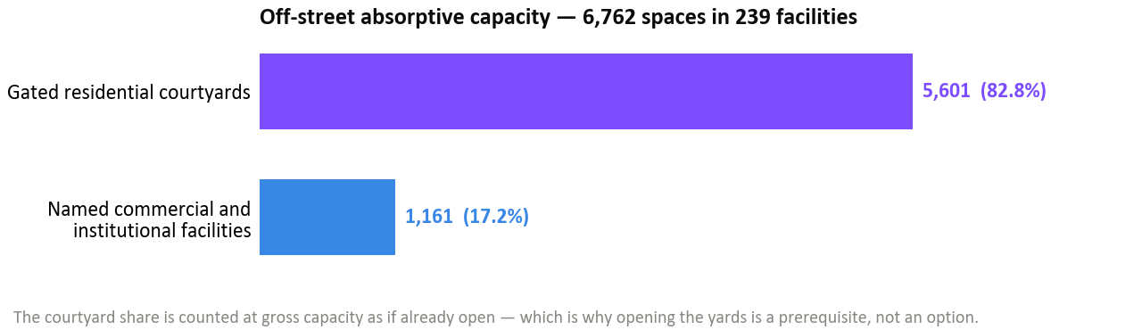
Figure 21 - Available absorptive capacity (off-street)
- 1,730 on-street spaces on cross-streets within the influence area, many of which are currently underutilised and could accommodate additional demand through formal delineation (1,505 of these spaces are still free to park and the city could turn them into Zone A/B paid parking).
- Measured absorption (surveyed areas). Of the peak displaced demand, surviving on-street capacity absorbs about 35% (10% in the Kentron core, 0% in Komitas, up to 97% in Malatia-Sebastia). The balance is closed by off-street capacity - but 83% of the absorptive capacity counted (1,935 of 2,326 spaces) is off-street rather than kerbside, and that off-street stock is 91% gated residential courtyard by facility count (83% by capacity), counted at gross capacity as if already open. Re-absorption approaching 100% in aggregate therefore draws mainly on off-street capacity rather than on the kerb; the measures that address this are set out in the companion Parking Analysis Report (Output 10).
- Measured off-street occupancy (field survey). The off-street side of this balance is now partly observed, not only inventoried. In each of the six areas the survey recorded hourly occupancy in one representative off-street facility (457 surveyed spaces in total) using the same licence-plate method as on-street. Averaged across the day these accessible facilities run about 48% full, so real off-street headroom demonstrably exists. At the peak hour, however, three of the six are already at or beyond capacity (Nalbandyan 142%, Komitas City 101%, Palace 100%) and only three keep meaningful spare (Garegin 45%, Shiraz 59%, Sebastia 77%). Each of these is a single facility measured at its own busiest hour, and a reading above 100% is a real measure of overflow rather than a data error; the chapter on the field occupancy survey sets out in detail how it arises. These surveyed facilities are accordingly excluded from the absorptive-capacity figure above - they already carry their own demand - so the off-street capacity counted above refers to the still-closed residential yards that could not be surveyed.

Area | Surveyed off-street facility | Formal spaces | Avg. occupancy | Peak-hour occupancy
Kentron (Corridor 1 core) | Nalbandyan yard | 60 | 81% | 142%
Komitas Avenue | Komitas City lot | 123 | 56% | 101%
Garegin Nzhdeh | GN off-street | 40 | 22% | 45%
Gai Avenue (Mega Mall) | Palace lot | 62 | 59% | 100%
Malatia-Sebastia | Sebastia yard | 101 | 32% | 77%
Shiraz / Hasratyan | Shiraz off-street | 71 | 37% | 59%
All six (total / weighted avg.) | - | 457 | 48% | -

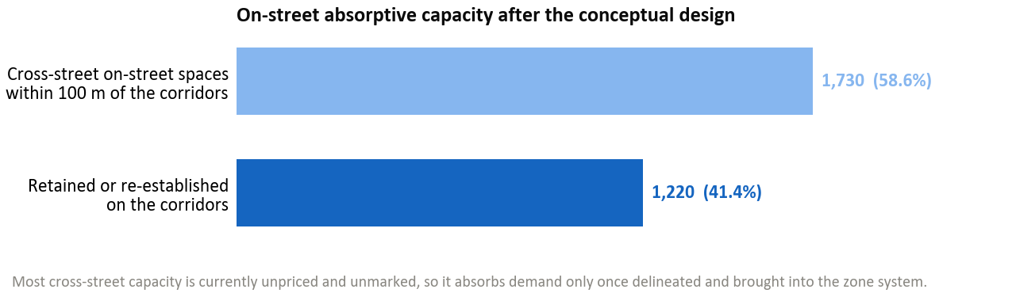
Figure 22 - Available absorptive capacity (on-street)

Conclusions
The parking supply inventory for the Yerevan bus priority corridor project provides a comprehensive, georeferenced evidence base covering 14,587 parking spaces on Corridors 1 and 2 and their 100-metre influence areas. The key conclusions are:
- The survey documented 7,825 on-street parking spaces and 6,762 off-street spaces within Corridors 1 and 2 and their 100-metre influence areas.
- Only 780 of the 6,095 on-corridor on-street spaces (12.8%) are within the paid parking system (246 in Zone A, 534 in Zone B). The remaining 87.2% are free or unregulated, confirming the informal nature of most corridor parking. Only 20% of the on-corridor kerb carries signage and 14% carries marking.
- The conceptual corridor designs remove 4,875 of the 6,095 on-corridor on-street spaces, 1,480 on Corridor 1 and 3,395 on Corridor 2, and retain or re-establish 1,220. Measured against the impact area, those 4,875 spaces are 62% of the 7,825 on-street spaces within the corridors and their 100-metre influence area, and 33% of all 14,587 spaces once off-street is included.
- Available absorptive capacity includes 6,762 off-street spaces and 1,730 cross-street on-street spaces, of which 1,505 are currently free to park and could be brought into the Zone A/B paid system. Most of the off-street stock (5,601 spaces) is gated residential courtyards that are not open for public parking today.
- The full interactive results are available at https://yerevan-parking.vercel.app for stakeholder review.
- Mitigation measures are detailed in the companion Parking Analysis Report (Output 10).

